Problem Statement

Product Dissection for top leading Platforms

Welcome to this case study on dissecting and designing products for top leading platforms. In this case study, you will delve into the intriguing world of schema design for a prominent platform of your choice. Your task is to choose a top leading platform, research its features, and meticulously craft a schema design that encapsulates the essence of its functionality. By focusing on key entities, attributes, and relationships, you will gain invaluable insights into how data architecture drives the platform's effectiveness.

Step 1: Choose a Leading Platform
Select a leading platform of your choice, which could span various domains such as social media, e-commerce, finance, or any other industry. This choice will form the foundation of your exploration into its schema design.

Step 2: Research:
Thoroughly research the platform you have selected. Investigate its core features, functionalities, and user interactions. Identify the top features that define its user experience and contribute significantly to its popularity.

Step 3: Product Dissection and Real World Problems solved by the platform
In this step, you will meticulously analyse the platform's standout features and how they provide innovative solutions to real-world challenges. By identifying key functionalities that resonate with users, you'll unravel how the platform effectively addresses problems and enhances user experiences. This dissection will serve as the foundation for understanding how the schema design aligns with the platform's core objectives.

Step 4: Case Study on the real world problems and approach to solving them
In this pivotal step, you will expand on the real-world challenges uncovered in Step 3 through a comprehensive case study. Delve into specific instances where users encountered difficulties and showcase how the platform's unique features provided effective solutions. By dissecting the approach taken by the platform to overcome these challenges, you'll gain a deeper appreciation for the platform's user-centric design philosophy and how it shapes the schema design.

Step 5: Schema Design Based on Top Features
Based on the features you have identified, craft a schema design that reflects the platform's data structure. Focus on the key entities, attributes, and relationships that underpin the chosen features. Your schema should capture the essence of how the platform organises and utilises its data.

Step 6: Rationale Behind the Design
While creating the schema design, consider the rationale behind the platform's choices. Reflect on why certain entities and relationships were chosen and how they align with the platform's goals. This will help you understand the strategic decisions driving the schema's architecture.

Step 7: Create an ER Diagram
Utilise tools like the Miro platform or similar applications to create an illustrative Entity-Relationship (ER) diagram. This diagram should vividly depict the entities, attributes, and relationships present within your schema design. The ER diagram will serve as a visual representation of your insights.

Step 8: Presentation of Findings
Present your findings in a clear and concise manner. Showcase your understanding of how the schema design impacts the platform's functionality and user experience. Explain how your chosen features are integrated into the schema and how the schema's structure supports the platform's objectives.

Task Details:

- Answer Submission: Your submission should include well-structured solutions for all provided questions related to product schema designs.

- Video Creation: Create an informative and engaging video where you thoroughly explain the Case Study.

- Depth and Clarity: Ensure your solutions are detailed and showcase your understanding of product schema design principles. Similarly, in the video, provide clear explanations that are easy to understand for a wide audience.

- Creativity Encouraged: You are welcome to utilise visuals, diagrams, or creative elements to enhance the clarity and impact of your explanations.

Note:
- Duplicate this document and proceed to write your solutions and prepare your video.
- Include the video link in this document before final submission.

Best of luck in completing this project and showcasing your prowess in dissecting and designing product schema for leading platforms! For reference, we have also conducted a case study on Instagram, which you can find below. This case study will provide you with valuable insights into how schema design plays a pivotal role in shaping the functionality and success of a prominent platform.


Product Dissection for Amazon

Company Overview:

Amazon was founded by Jeff Bezos in his garage in Bellevue, Washington, on July 5, 1994. Initially an online marketplace for books, it has expanded into a multitude of product categories, earning it the moniker "The Everything Store." It has multiple subsidiaries, including Amazon Web Services (cloud computing), Zoox (autonomous vehicles), Kuiper Systems (satellite Internet), and Amazon Lab126 (computer hardware R&D). Other subsidiaries include Ring, Twitch, IMDb, MGM Holdings, and Whole Foods Market.

Product Dissection and Real-World Problems Solved by Amazon:

Amazon is one of the trending e-commerce powerhouses where we can buy and sell products. Initially, Amazon focused on books, but over time, it expanded to include a wide range of products, from groceries to multifunctional machines. By addressing real-world problems through a multifaceted platform, Amazon's core features and functionalities span diverse areas, ensuring convenience, choice, and seamless experiences for its global user base.
Amazon has become a dominant player not just in e-commerce but also in many other industries, including Amazon Prime, cloud services, subscription services, third-party selling, and more. Some of its core components and features include:
1.Amazon Prime: Amazon Prime is a subscription service that offers numerous benefits, including fast delivery, streaming services, and exclusive deals.
2.Cloud Service: AWS (Amazon Web Services) is a significant part of Amazon, providing storage and cloud computing solutions.
3.Membership & Subscription service: Amazon's main service is Amazon Prime, which provides numerous benefits such as free delivery offers. Other subscription services include family-oriented daily needs products and digital streaming content. These services enhance customer loyalty and engagement.
4.Third party seller: Amazon allows third-party sellers to list their products on the platform, facilitating engagement with a wider range of sellers. Additionally, sellers can offer refurbished items at reduced costs, providing customers with more options at lower prices.
5.Global presence: Amazon is a trending company worldwide, tailoring its product offerings to local markets.
6.Digital content: Apart from the physical products, Amazon provides digital content such as e-book, music, movies and audiobooks.
7.Product listing: Amazon's product listings are comprehensive, featuring photos, videos, prices, detailed descriptions, specifications, seller information, and customer reviews. This wealth of information helps customers compare different products and make informed purchase decisions effortlessly.

Case Study: Real-World Problems and Amazon's Innovative Solutions
Amazon, as a leading e-commerce platform, encounters various challenges such as product delivery fulfillment, customer engagement, and competition from other companies. To address these challenges effectively, innovative solutions are required to benefit both the company and its users.

Problem 1: Product delivery fulfilment

Real-World Challenge: Many customers order products in emergencies. For example, if a customer needs a fishing net because they are receiving more fishing orders, they should receive the product on time instead of waiting for a week.

Amazon's Solution:
Amazon should consider establishing a logistics and fulfillment center where they can streamline the delivery process using AI models. After receiving an order, the seller and customer should be able to communicate with a service agent to help dispatch and deliver the item quickly.

Problem 2: Customer engagement
Real-World Challenge: Customers are Amazon's top priority. Amazon aims to ensure that customers engage with its services and prefer Amazon over any other platform.

Amazon's Solution:
Amazon can recommend the most searched items, provide notifications during offer seasons, and collaborate with top social media influencers to increase user engagement and connectivity with Amazon. Additionally, Amazon can offer personalized recommendations based on customer reviews and highly rated products. Investing in customer service is also crucial for ensuring a positive experience and building customer loyalty.

Problem 3: Competition with others
Real-World Challenge: Facing competition in retail services with other e-commerce websites that offer more discounts and facilities can be challenging for Amazon.

Amazon's Solution:
Investing in new technologies like AWS and subscription services, offering free trials, and hiring more innovative people who can drive the organization forward and take risks are indeed strategic moves that can help Amazon stay ahead in the competitive landscape.

Problem 4: Privacy and security
Real-World Challenge: Ensuring the privacy of data registered by users and their transactions, dealing with fraudulent activities on the platform, and providing security for account details and addresses are all key priorities for Amazon.

Amazon's Solution:
Amazon can implement robust cybersecurity measures, encryption protocols, and compliance with data protection regulations to safeguard user data and privacy. Additionally, Amazon can employ machine learning algorithms and AI tools to detect and prevent counterfeit listings.

Problem 5: Return and cancellation
Real-World Challenge: Dealing with more returns and cancellations of orders can make it inconvenient for customers to buy products from Amazon.

Amazon's Solution:
Amazon can highlight products with more positive reviews and create a special team to investigate customer problems. If the issue is genuinely defective, they should offer a return or replacement; otherwise, they should only replace policies to ensure customer trustworthiness. Employing an AI model can ensure product security and correctness. Additionally, Amazon has strict seller verification processes and buyer protection policies.

Conclusion:
Amazon's innovative solutions have redefined e-commerce retail services, offering a wide range of services to address real-world challenges and thrive in a competitive market. By leveraging Prime, AWS, Amazon Fresh, and various physical retail initiatives, businesses can enhance operational efficiency, customer engagement, and overall business performance. These solutions have significantly expanded Amazon's competitive edge in the e-commerce industry..

Top Features of Amazon:
- One-Click Ordering: Amazon allows customers to order with one click, skipping the cart process. This feature helps streamline and speed up purchases for customers.
- Amazon Prime: Amazon Prime provides users with benefits such as fast delivery and offers on products.
- Amazon Web Service: Amazon Web Services (AWS) is a cloud storage and computing platform used worldwide for business purposes.
- Amazon Fresh: Amazon Fresh allows customers to purchase groceries and select their preferred location for delivery or pickup.
- Amazon Advertising: Amazon Advertising is utilized by Amazon to promote products and services through various advertising mediums.
- Alexa: Alexa is Amazon's home service gadget that operates on voice commands, such as playing music or controlling smart devices like lights and fans. It can only connect with compatible smart devices.
- Fulfilment by Amazon (FBA): FBA is a service for third-party sellers to connect with Amazon for shipping and packaging services.

Schema Description:
The schema for Amazon involves multiple entities representing different aspects of the platform. These entities include customer, seller, product, order, and more. Each entity has specific attributes that describe its properties and relationships with other entities.

Customer Entity:
The customer entity contains information about each customer:

- customer_id (Primary Key): A unique identifier for each customer.
- customer_name: The name of each customer to display.
- customer_phone:Customer phone number to get connected.
- customer_email: Email address of the customer.
- join_date: The date when the customer joined Amazon.

Address Entity:
The Address entity contains information about the address of the customer:

- address_id (Primary Key): A unique identifier for each product .
- customer_id (Foreign Key): An identifier for the customer.
- building_name : Name of the building.
- street: Street to residency.
- area: Area of residency.
- zipcode: Area code of the customer’s residency.
- state: State of the customer.
- country: Country of the customer.

Seller Entity:
The seller entity contains information about each seller:
seller_id (Primary Key): A unique identifier for each seller.
- seller_name: The name of each seller to display.
- seller_phone:Seller phone number to get connected.
- seller_email: Email address of the seller.
- seller_address: An address of the seller.
- join_date: The date when the seller joined Amazon.
- seller_rating: Rating of the seller.

Product Entity:
The product entity contains information about the products:

- product_id (Primary Key): A unique identifier for each product .
- seller_id (Foreign Key): An identifier for the seller.
- product_name: The name of each product to display.
- product_price: Price of the product.
- product_type: Type of the product.

Order Entity:
The order entity contains information about the orders:

- order_id (Primary Key): A unique identifier for each order .
- product_id (Foreign Key): An identifier for the product.
- customer_id (Foreign Key): An identifier for the customer.
- order_count: Total quantity of the order.
- order_date: Date on which order is placed.
- price: Total price of the product.

Order_delivery Entity:
The order_delivery entity contains information about the delivery of order:

- delivery_id (Primary Key): A unique identifier for each delivery .
- order_id (Foreign Key): An identifier for the order.
- delivery_status: Status of order delivery
- delivery_date: Date on which order is delivered.

Order_payment Entity:
The order_payment entity contains information about the payment status of order:

- payment_id (Primary Key): A unique identifier for each payment .
- order_id (Foreign Key): An identifier for the order.
- payment_mode : Mode of payment.
- amount: Total amount paid for the order.
- transaction_date: Date on which transaction is made.

Review Entity:
The review entity contains information about the reviews of the customer on product:

- review_id (Primary Key): A unique identifier for each review .
- product_id (Foreign Key): An identifier for the product.
- customer_id (Foreign Key): An identifier for the customer.
- seller_id (Foreign Key): An identifier for the seller.
- rating: rating for the product.
- coment: comment on the product.
- date: Date of review and comments.

Relationships :

- customer has address – One to many relationships, each customer has one address but for office or work it may be many.
- customer has orders – One to many relationships, each customer can make may orders.
- customer has review – One to many relationships, each customer can write many reviews.
- seller has product – One to many relationships, each seller can have many products.
- product has seller – One to one relationship, each product can have one seller.
- seller has review – One to many relationships, each seller can have many reviews based on products.
- order has payment status – One to one relationship, each order has one payment status.
- order has order delivery status – One to one relationship, each order has one delivery status.
- product has orders – Many to many relationships, many products has many orders.

ER Diagram:

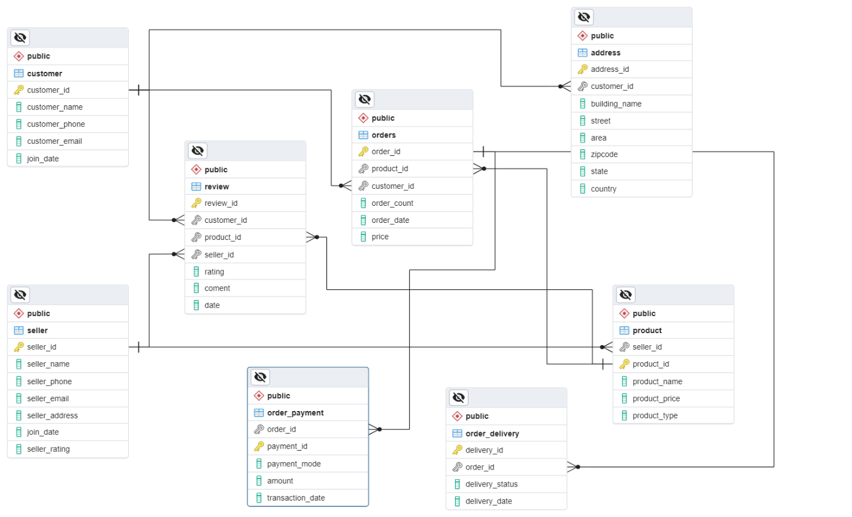

Conclusion
In this case study, we delved into the design of Amazon's schema and Entity-Relationship diagram. We observed that many columns contain different data based on various entities. Foreign keys serve as pivotal components in this process, acting as a bridge between entities in different tables. Furthermore, we deliberately defined the relationships of each column's data to other columns' data and carefully mapped out how they interconnect and interact with one another in the datasets.

